
NORTHERN EDUCATION DIVISION MOCK EXAMINATION
2026 MALAWI SCHOOL CERTIFICATE OF EDUCATION
MATHEMATICS
Subject Number: M131/I
Thursday, 19th March Time Allowed: 2 hours
8:00 – 10:00 am
PAPER I
(100 marks)
Instructions

- This paper contains 13 pages. Please check
- Answer all the 20 questions in this paper
- The maximum number of marks for each answer is indicated against each question
- Write your answers in the spaces provided on the question paper.
- Scientific calculators may be used.
- The graph paper and blank answer sheet at the end of the question paper can be used if required. Do not tear them off.
- All working must be clearly shown.
- Write your Name at the top of every page

Question Number | Tick if answered | Do not write in these columns
1
2
3
4
5
6
7
8
9
10
11
12
13
14
15
16
17
18
19
20
Turn over
- Factorize completely: $3y^{2}-6y-9.$ (4 marks)

- Simplify $\frac{1}{\sqrt{7}}-\frac{2}{5\sqrt{7}}$ , giving the answer with a rational denominator.
(5 marks)

- Make $p$ subject of the formula: $n=\frac{y}{p}\left(m^{2}-\frac{p}{a}\right).$ (4 marks)

- Given that $f\left(x\right)=$ $\sqrt[3]{x^{2}-8}$ and $f\left(x-2\right)=2.$ Find the values of $x.$
(5 marks)

- Solve the equation $1-5x-2x^{2}=0,$ giving the answer to 2 significant figures. (6 marks)

- Given that $A=\left(\begin{matrix}-1 & 3 \\ 2 & 0\end{matrix}\right)$ and $B=\left(\begin{matrix}-2 & 0 \\ 1 & -3\end{matrix}\right)$. Evaluate $A^{2}-AB.$
(5 marks)

- Figure 1 shows a circle ABCD centre O in which AE = $32x$ cm and EC = $18x$cm.
A

32$x$ cm O
D 18$x$cm E B
C
Figure 1.
Calculate the length of DB in terms of $x.$ (5 marks)

- The end points of a 10 cm diameter are A (5, w) and B ($-1,7)$ respectively. Calculate the coordinates of the centre when w is negative. (5 marks)

- A metallic sphere of volume 770 cm³ is recast into a cylinder of length 5 cm, calculate the surface area of a cylinder. Take $π=$ $\frac{22}{7}.$ (5 marks)

- Given that $\vec{OC}$ is parallel to $\left(\begin{matrix}3 \\ 4\end{matrix}\right)$ and $\left|\vec{OC}\right|=30.$ Find $\vec{OC}.$ (6 marks)

- If $x-3$ is a factor of $x^{3}+p^{2}x^{2}-11x-30,$ find the values of $p.$
(4 marks)

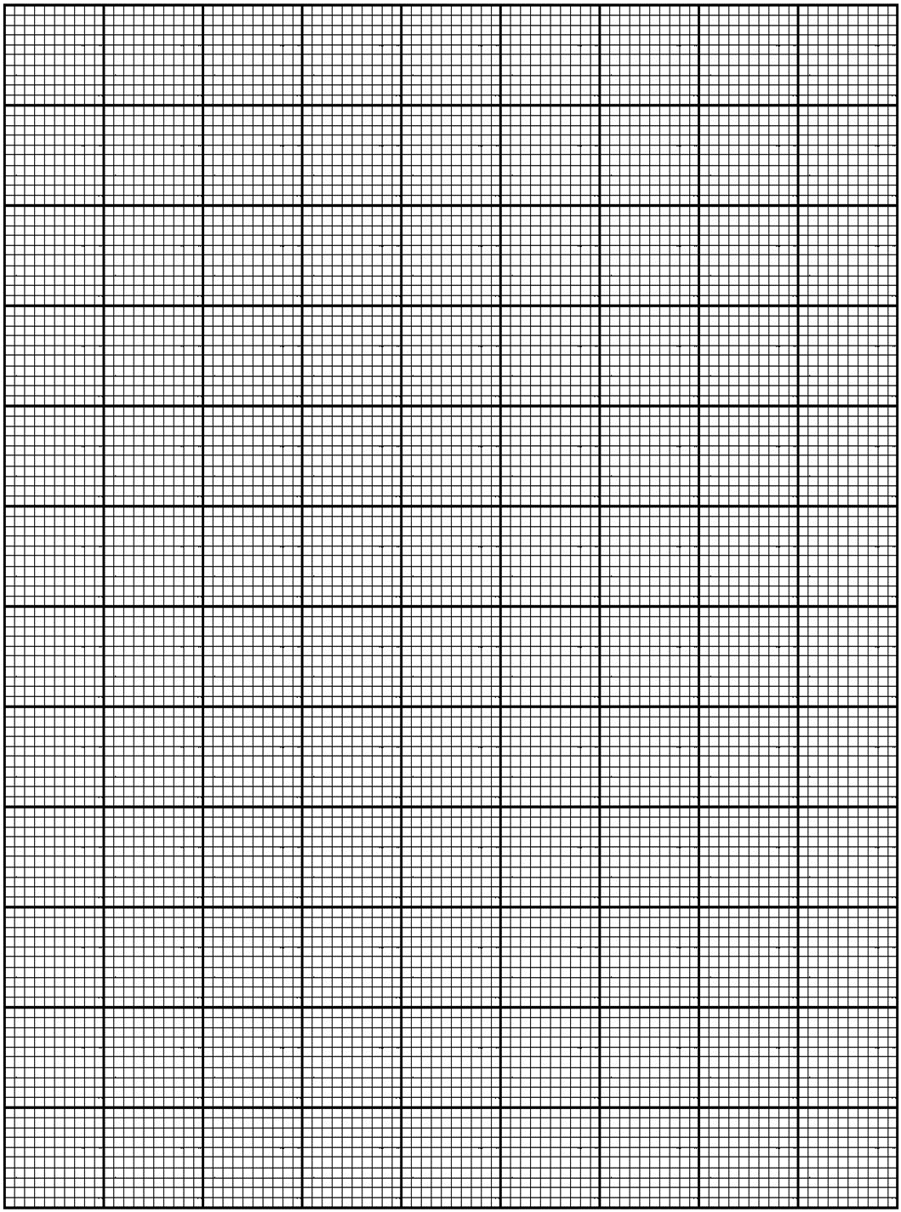
- A body starts with a speed of 10 m/s and accelerates uniformly to a speed of 30 m/s for 5 seconds. It then further accelerates at 5 m/s² in the next 10 seconds before going to rest in another 15 seconds. Sketch the graph for the journey. (5 marks)
- If $x+1, 2x-1$ and $x+5$ are three consecutive terms of the arithmetic progression (A.P), calculate the sum of the first 10 terms.
(5 marks)

- Given that $p$ varies directly as the cube of $x$ and inversely as the square root of $y.$ When $p=32, x=2$ and $y=9.$ Find $y$ when $p=8$ and $x=\frac{1}{2}.$
(6 marks)

- Figure 2 shows two isosceles triangles YXZ and YMN. N and M are points on YZ and YX respectively such that NM is parallel to ZX. YO = 2cm, OW = 4 cm and ZX = 15 cm.
Y
2cm
N O M
4cm
Z W X
15 cm
Figure 2.
Calculate the area of trapezium NMXZ. (5 marks)

- The variance of the data: $2x, 3x-4, 3x+4$ and $4x$is 16. Find the values of $x.$ (5 marks)

- The angles of elevation and depression of the top and bottom of the tower from the top of a 50 m tall building are 70⁰ and 25⁰ respectively. Calculate the height of a tower, giving the answer to the nearest meter. (6 marks)

- Figure 3 shows a circle QXNT. PQR is a tangent at Q, PXT is a straight line, such that angle QNT = 66⁰ and angle XPQ = 32⁰.
N
66⁰ T
X
P 32⁰ Q R
Figure 3.
Calculate angle XQT. (5 marks)

- Figure 4 below shows a region M bounded by three inequalities.
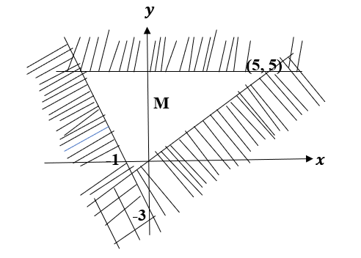
Figure 4.
Write down the three inequalities bounded by region M. (4 marks)

- Point $x\left(-3,2\right)$is translated to $x'$ by translation vector $K=\left({-1 \atop 4}\right)$ followed by translation Y =$\left(\begin{aligned}a \\ b\end{aligned}\right)$. If $x'(6,8)$ find translation vector Y. (5 marks)

END OF QUESTION PAPER
NB: This paper contains 14 printed pages.

